How to create an Amazon S3 bucket ?

* <https://aws.amazon.com>
* Click on all services.
* Go to storage.
* Click on S3.

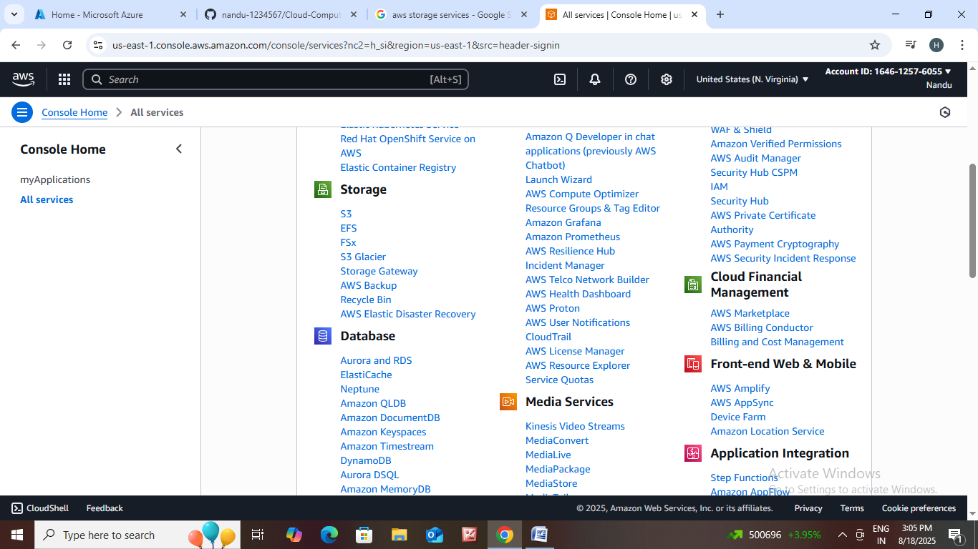

* In Amazon S3 click on general purpose buckets.
* Click on create bucket.
* Buckets are containers for data stored in S3.

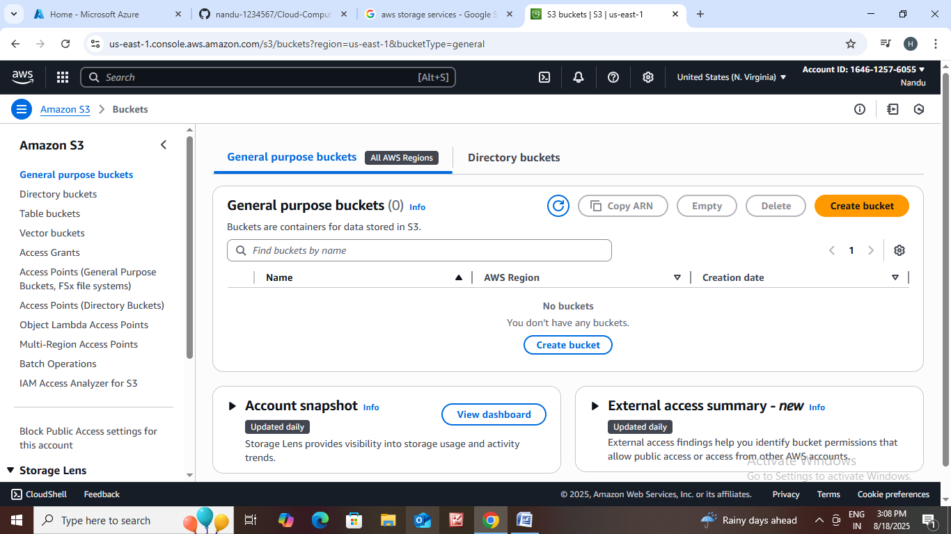

* AWS region : Choose any region.
* Bucket Type :

* General Purpose - Recommended for most use cases and access patterns. General purpose buckets are the original S3 bucket type. They allow a mix of storage classes that redundantly store objects across multiple Availability Zones.

* Directory - Recommended for low-latency use cases. These buckets use only the S3 Express One Zone storage class, which provides faster processing of data within a single Availability Zone.

* Bucket Name : Take an examples like online apps

Ex: flipkartstorage.

* **Object Ownership :** Control ownership of objects written to this bucket from other AWS accounts and the use of access control lists (ACLs). Object ownership determines who can specify access to objects.

**\*** ACLs disabled (recommended) - All objects in this bucket are owned by this account. Access to this bucket and its objects is specified using only policies.

* ACLs enabled : Objects in this buckets can be owned by other Microsoft accounts.

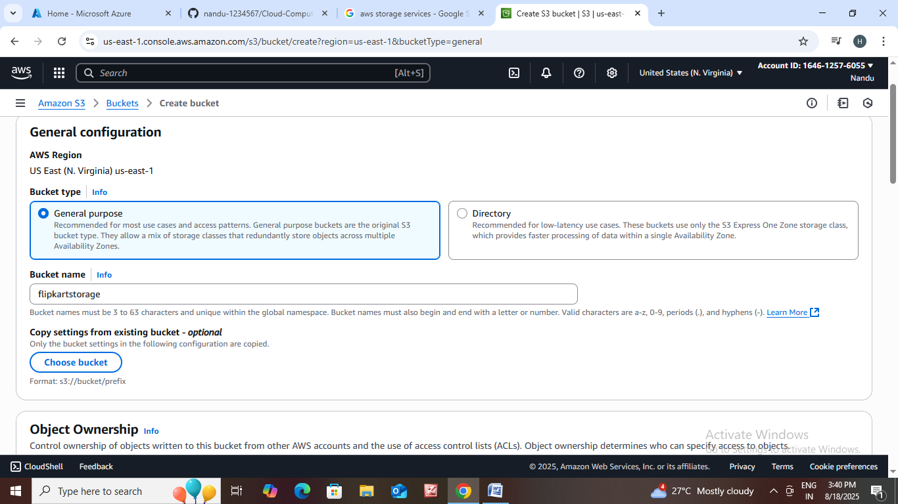

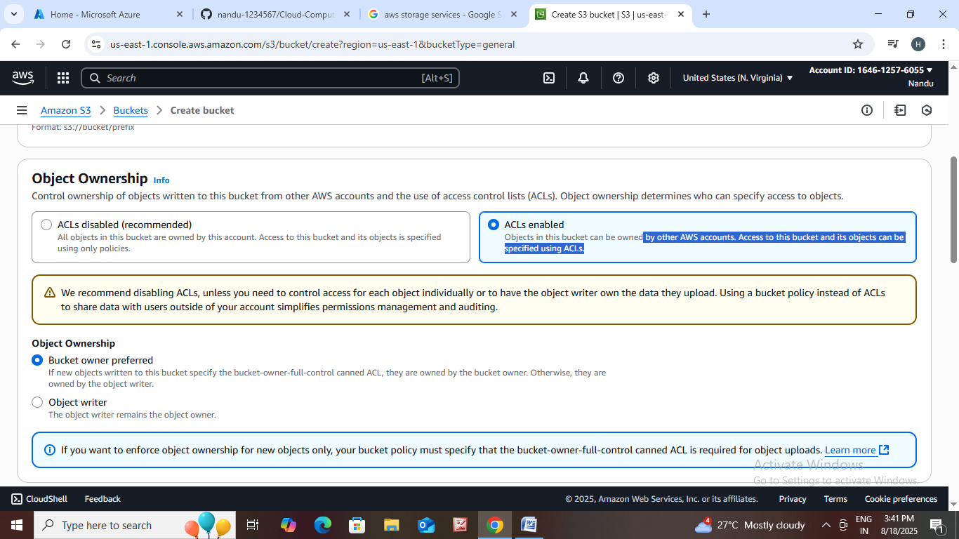

* Block all Public access settings.

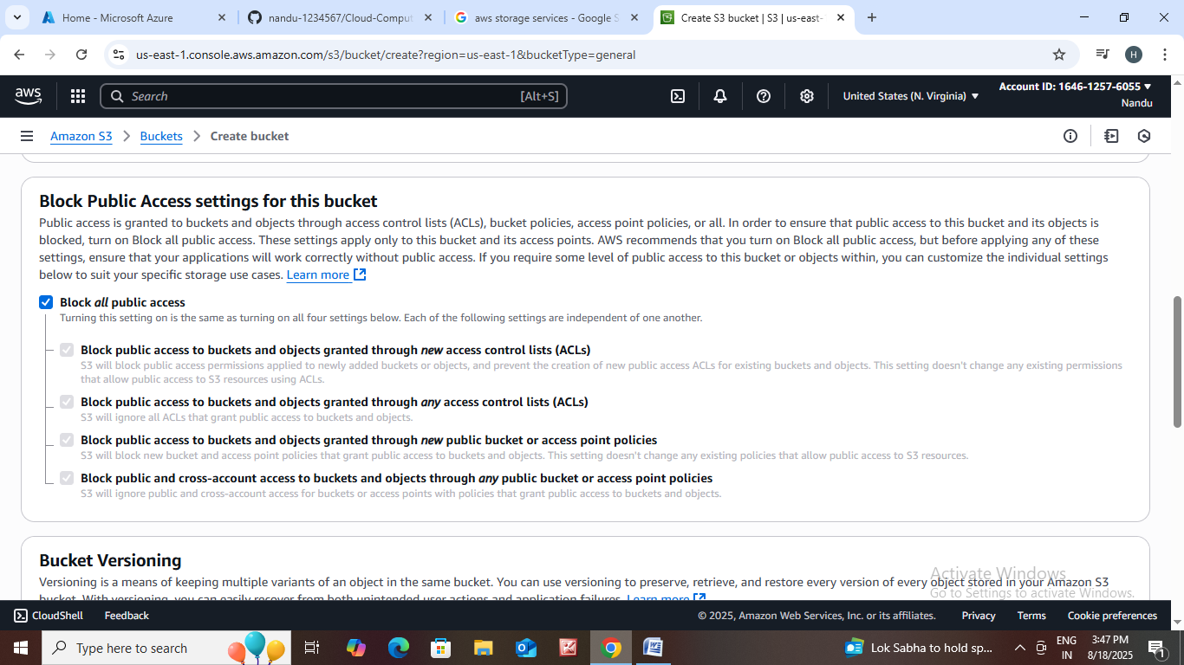

* Bucket Versioning : Versioning is a means of keeping multiple variants of an object in the same bucket. Choose enable or disable.
* Tags : You can use bucket tags to track storage costs and organize buckets.

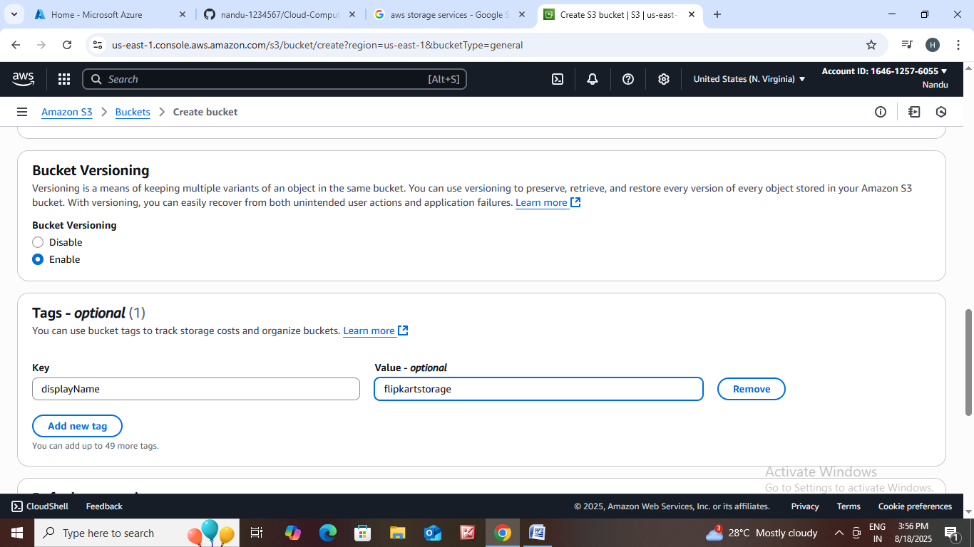

* **Default encryption :** Server-side encryption is automatically applied to new objects stored in this bucket.

**\*** Server-side encryption with Amazon S3 managed keys (SSE-S3)

**\*** Server-side encryption with AWS Key Management Service keys (SSE-KMS)

**\*** Dual-layer server-side encryption with AWS Key Management Service keys (DSSE-KMS)

* **Bucket Key :** Using an S3 Bucket Key for SSE-KMS reduces encryption costs by lowering calls to AWSKMS. S3 Bucket Keys aren't supported for DSSE-KMS.

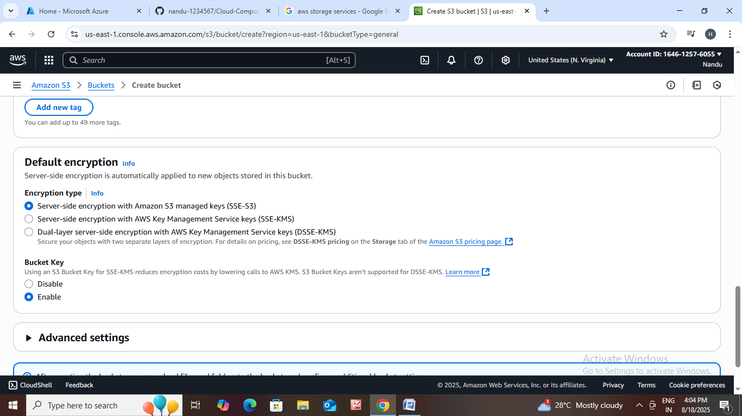

* **Then click on create bucket.**

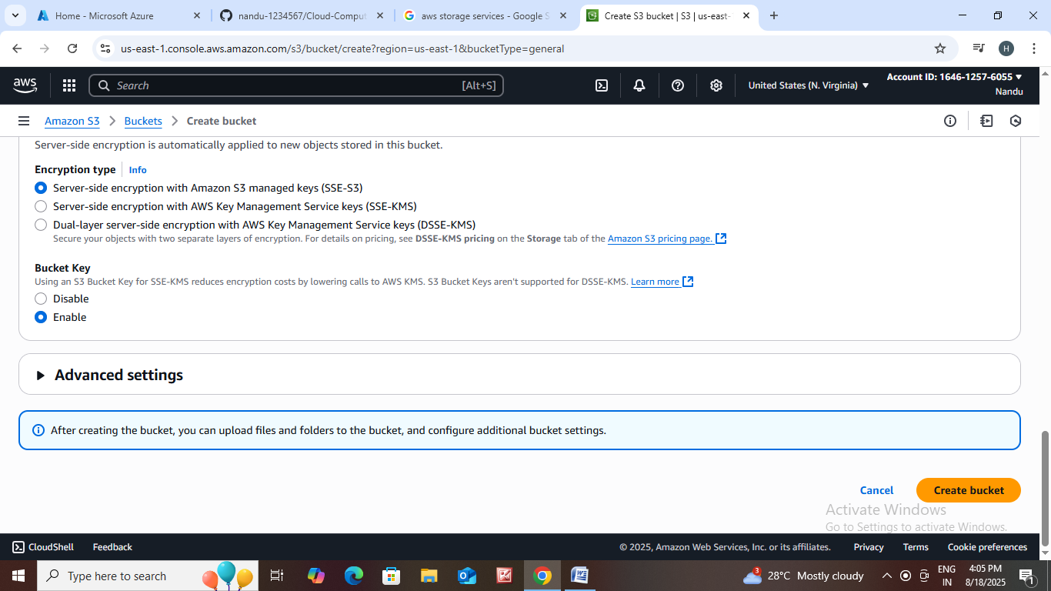

* After creating bucket click on flipkartstorage1.

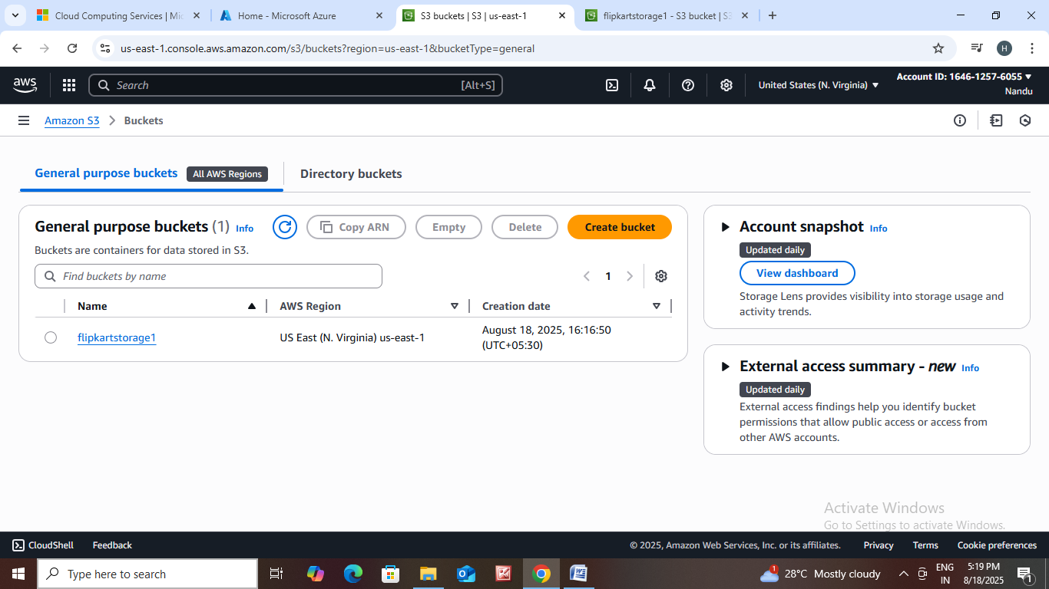

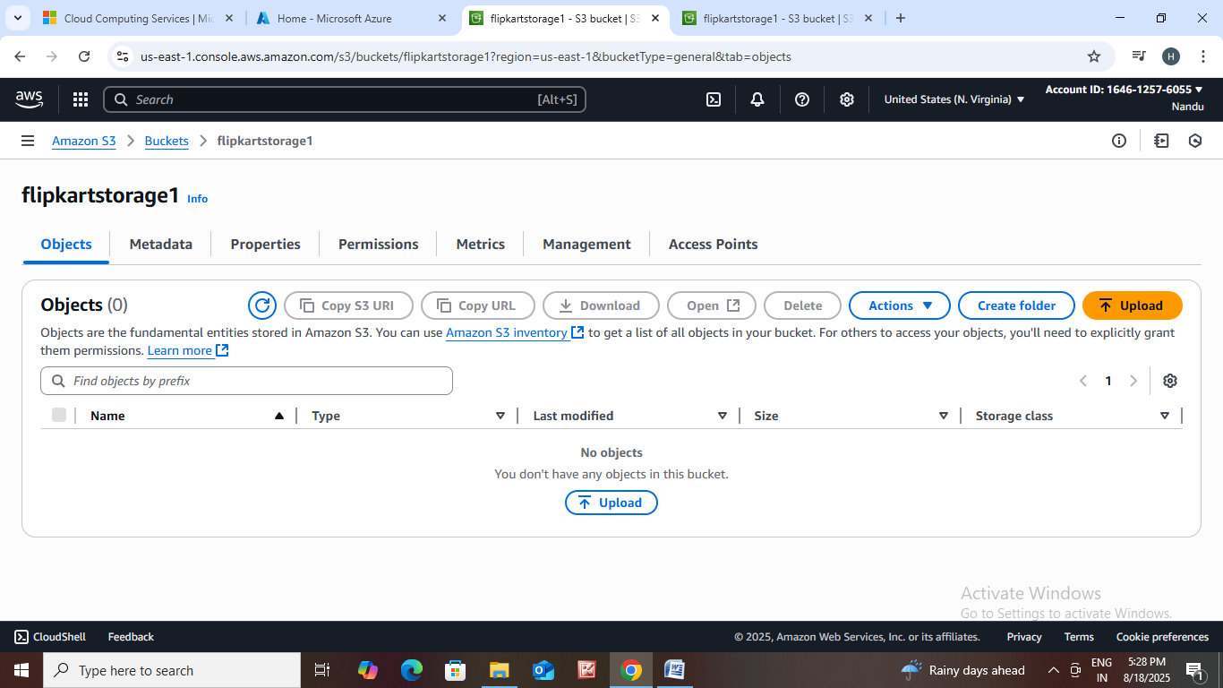

## Click on upload.

## After clicking on upload we can upload files and folders in it.

## 

## We can store files and folders on it.